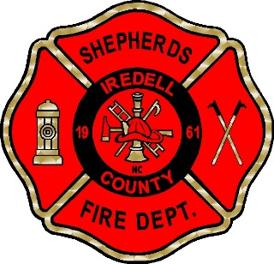
SHEPHERDS FIRE & RESCUE INC.
2014 CHARLOTTE HWY * MOORESVILLE NC 28117 * 704-663-1245

EMPLOYMENT APPLICATION CHECKLIST

Please provide the following information with your Application for Employment. All pages must be completed, and all requested documentation below must be provided before an application will be considered.

      - Employment application pages 1-4, signed and dated

      - Copy of Birth Certificate

      - Copy of valid North Carolina Driver’s License

      - Copy of High School Diploma or GED

      - Copies of any certificates pertaining to the Fire Department or Medical Training, if applicable

      - DD-214 Long Form, if you have prior Military service

      - Signed Authorization for Background Check

Failure to submit a complete application packet may result in rejection of entire
application.

Click or tap here to sign. Click or tap to enter the date.

Applicant Signature Date

