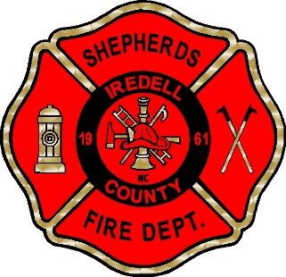
SHEPHERDS FIRE – RESCUE, INC.
2014 CHARLOTTE HWY * MOORESVILLE NC 28117 * 704-663-1245

FIREFIGHTER – JOB DESCRIPTION

Responsibilities:
- Respond to fire alarms with a company; lays and connects hose; holds nozzles and directs water streams; climbs ladders; uses chemical fire extinguishers, bars, hooks, lines and other equipment
- Ventilates burning buildings by opening windows and skylights or by cutting holes in roofs and floors
- Provides medical assistance to fire victims or as fire responders to emergency situations, until arrival of county medical unit
- Performs salvage operations such as applying salvage covers, sweeping water and removing debris
- Participates in fire drills and attends training classes in apparatus operation, firefighting, emergency medical and related subjects; studies assigned materials relating to firefighting and fire prevention
- Inspects buildings and premises for familiarization; checks for fire hazards; participates in the inspection and maintenance of fire hydrants
- Operates fire apparatus and assumes command of a fire company on an occasional basis
- Performs general maintenance and cleaning work in the upkeep of departmental apparatus, equipment, and structures; cleans kitchen, sleeping quarters, walls, and floors; washes, hang and dries hose; washes, cleans and polishes apparatus
- Perform related work as required

Physical Requirements:
Firefighters must have the agility and physical strength to do prolonged and arduous work under hazardous conditions. The includes, but is not limited to the ability to lift, move and maintain position on items (e.g. charged hoses) up to 90 pounds; push objects up to 25 pounds; pull objects from 25 to 50 pounds, and lift or pull victims weighing more than 150 pounds.

